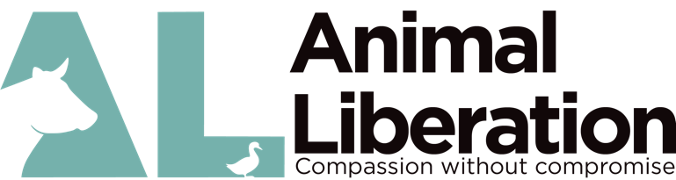
Animal Liberation’s Policy on the Use of Content (Videos/Images)
by other groups or individuals

Content (videos/images) licenced and owned by Animal Liberation may be used, after receiving permission in writing, from Animal Liberation. To receive permission, you must submit the application below, with details on how the footage will be used, and the purpose for using the content. You must also comply with the conditions outlined below. Animal Liberation reserves the right to retract approval after the final image/video has been assessed.

- We grant approval on a case by case basis, however, the following conditions must always be met:
- The content (videos/images) will be used only for information, education or raising community awareness;
- The content (videos/images) will be used in a manner consistent with the relevant Animal Liberation policy and/or campaign;
- When granted permission for the use of the content (video/image), it is for one-time usage only (you must reapply for future uses);
- The content (videos/images) will not be significantly altered or edited,
- Information or statements that accompany the content (video/image) must be confirmed as accurate and acceptable by Animal Liberation, and;
- The content (videos/images) will not be used for fundraising, commercial, or related purposes.

- When using Animal Liberation’s footage and/or images, the following acknowledgements are required:
- Photos: must acknowledge Animal Liberation, for example ‘Animal Liberation’ in a readable size and placed in a prominent position on, beneath, or beside the still images, and will be present at all times whilst the images are in use.
- Video footage: must acknowledge Animal Liberation, with either our name or logo, in a prominent position, such as beneath or beside the video, and will be present at all times, as well as immediately after video footage, for a reasonable period. It will typically say ‘Footage by Animal Liberation’, with the Animal Liberation logo and website.
- Internet use of content: the acknowledgement will, in addition to the above, contain a link to Animal Liberation’s website, so that viewers can easily access to further material related to the relevant campaigns or investigation.

When submitting your application,
- Please provide a draft of how you intend to use the content (videos/images) supplied by Animal Liberation, for review and approval prior to publication. Please give our team sufficient notice for approvals.
- Animal Liberation reserves the right to retract permission for the use of the content (videos/images) where it judges that the use is not following guidelines above.
- Please provide details of the footage you are after, as we will not grant access to the entire album.
- Once you have created the final product (video or image use), please send it to our team for another review at – tech@animal-lib.org.au.
Further consideration

Animal Liberation is willing provide access to content (video/images) to help assist people in raising awareness about animal rights issues. Content supplied, however, remains the property of Animal Liberation, and the organisation must be credited.

Animal Liberation has granted ___________________ permission to use the content (images/video) featured in the following links for the use and inclusion in ___________________ only;

The above policy must be adhered to for each and every piece of content (images/videos), which has been approved for use by ___________________

Acknowledgement of footage is to be included in the closing credits in the form of written acknowledgement and the presentation of Animal Liberation’s logo.

I, _____________________________________ have read and agree to the terms and conditions set in this footage/image use agreement. I will adhere to conditions set by Animal Liberation.

Signed: _______________________________
Full Name: _______________________________

Address: _______________________________

Date: _______________________________

Animal Liberation office use only

Received date:-

Received by:-

Signed

